*Assignment 5*

*Instructor: Faisal Khan*

|  |  |  |
| --- | --- | --- |
| *Name* | *Student ID* | *Group#* |
| Neelesh Maharjan | C0838743 |  |
| Anila Sunny | C0842969 |  |
| Anupriya Haridas | C0860514 |  |
| Abhishek Arora | C0837189 |  |
| Arman Rohaj | C0860916 |  |

1-Use Documentation Comments where needed and use Javadoc to create HTML files for documentation.

2-In your project src folder add this word document with all your group members names and paste the screen shots of your output after each question.

2-Right Click on your Project Folder in Eclipse, Copy Option is available. Create a copy of the Project and upload the zipped folder using Moodle.

Create a Rest API Resource named Book for an online Library.You should be able to perform all the Crud Operations using the URLS like Inserting Book ,display

All books ,show a specific book based on id,update and delete a Book .Your

Model Class Book may have fields like id , name ,author

,price and genre .

Use Postman tool for testing this Rest Api and test the URLs for method calls.

Creating database with table Book . 10 marks

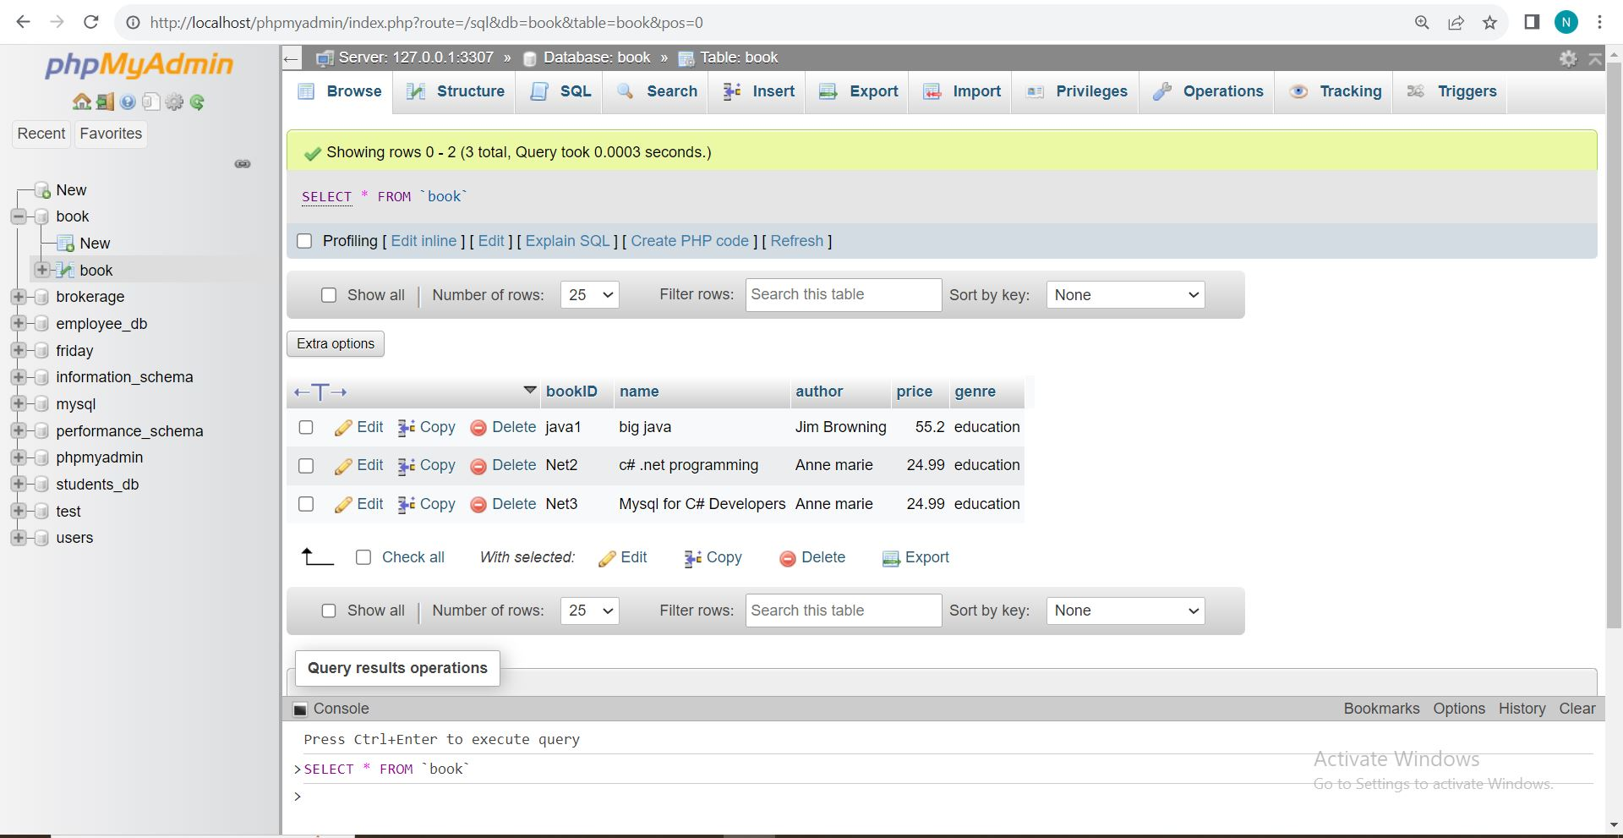

Creating Model Class Book . 10 marks

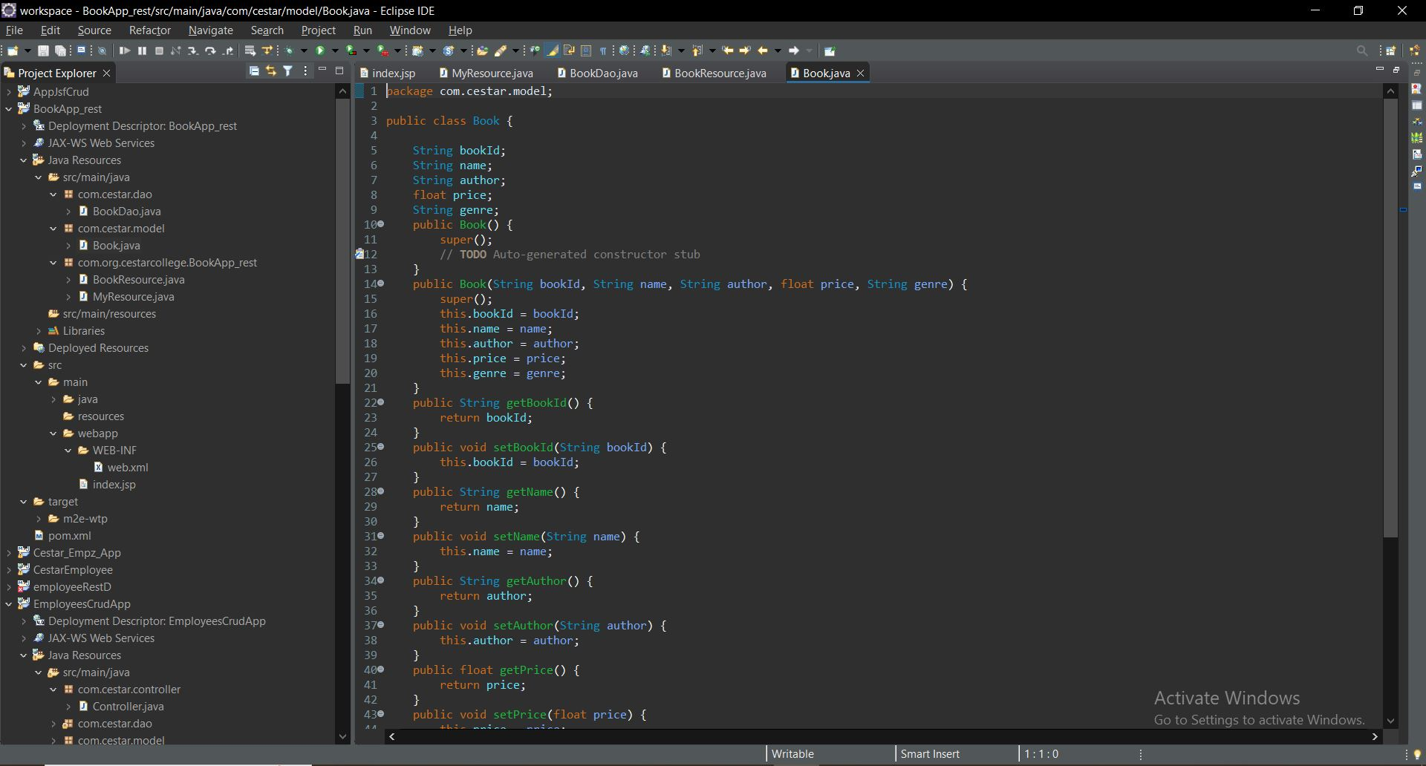

Creating dao class with all methods for Crud Operations. 30 marks

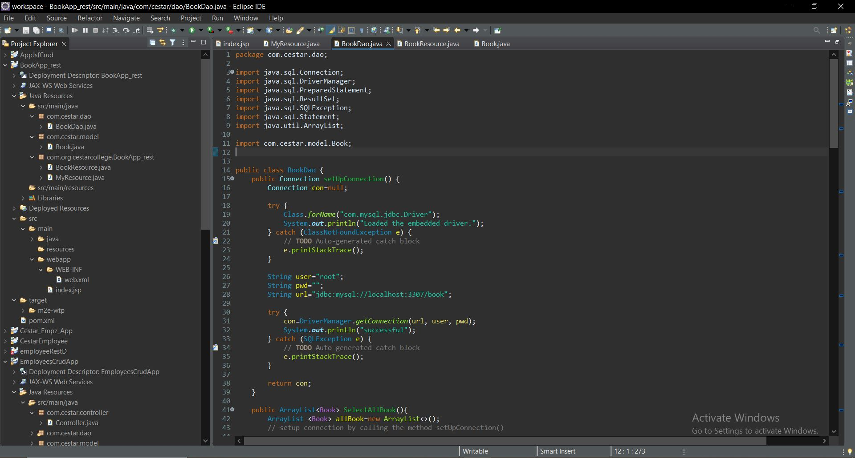

Creating a Rsource class with all http methods . 20 marks

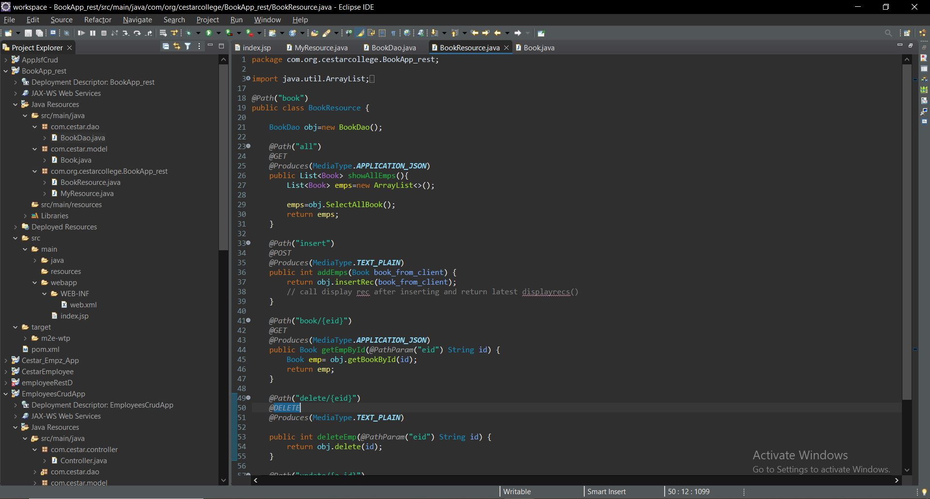

Showing proper response code using postman for each method. 30 marks

